

Policy and Guidance for Child-on-Child Abuse, Sexual Harassment & Sexual Violence

September 2026

This policy should be reviewed in line with other statutory guidance contained within:
- Keeping Children Safe in Education 2026 (particularly Part 5 – Child-on-child Sexual Violence & Sexual Harassment).
- Working Together to Safeguard Children (2026)
- Brackensdale Spencer Academy Safeguarding & Child Protection Policy

Contents

1 | Introduction |  | 2
2 | Aims |  | 2
3 | Understanding Child-on-Child Abuse |  | 2
4 | The Context |  | 4
5 | Vulnerable Groups |  | 4
6 | Responding to Alleged Incidents or Reports of Sexual Violence and Sexual Harassment |  | 5
7 | Risk and Needs Assessment |  | 5
8 | Action Following a Report of Sexual Violence and/or Sexual Harassment |  | 6
9 | Follow up Actions |  | 6
10 | Options to Manage the Report |  | 6
11 | Support for Children Affected by Sexual Violence |  | 7
12 | Physical Abuse |  | 8
13 | Online Behaviour |  | 9
14 | Prevention |  | 9
15 | Multi-Agency Working |  | 10
 | Appendix
 | Appendix 1: NSPCC Continuum guide - Responding to children who display sexualised behaviour and Hackett Continuum |  | 11
 | Appendix 2: Useful Publications and Websites |  | 12
 | Appendix 3: Risk & Needs Assessment |  | 13
 | Appendix 4: Flowchart: Managing Reports of Sexual Violence/Sexual Harassment |  | 16

- Introduction
Brackensdale Spencer Academy recognises that children are vulnerable to and capable of abusing other children. This includes verbal as well as physical abuse. Our Academy adopts a zero-tolerance approach towards child-on-child abuse and it will not be tolerated or passed off as part of “banter” or “growing up”.
We are committed to a whole academy approach to ensure the prevention, early identification, and appropriate management of child-on-child abuse within our Academy and beyond.
In cases where child-on-child abuse is identified we will follow our child protection procedures, taking a contextual approach to support all children and young people who have been affected by the situation, including family members.
This policy while touching on all forms of child-on child abuse, concentrates on child-on-child abuse in the context of sexual harassment and sexual violence. It is compliant with the statutory guidance on child-on-child abuse as set out in Keeping Children Safe in Education (September 2026) and should be read in conjunction with the Local Safeguarding Children Partnership (LSCP) Safeguarding Policy and Procedures.
For the purposes of this policy, we use the term 'victim' as it is widely recognised and understood. However, we acknowledge that not everyone who has experienced abuse identifies with this term. We will use the term that the individual is most comfortable with when managing any incident.
We use the terms 'alleged perpetrator(s)' and 'perpetrator(s)' as they are widely recognised. However, we carefully consider the use of these terms, especially in front of children, as the behaviour may have also harmed the perpetrator. Appropriate terminology will be determined on a case-by-case basis.

- Aims
The policy will: -
- Set out our strategies for preventing, identifying, and managing child-on-child abuse
- Take a contextual approach to safeguarding all children and young people involved. Acknowledging that children who have allegedly abused other children or displayed harmful sexual behaviour are themselves vulnerable and may have been abused by a child, peer, parents, or adults in the community
- Recognise that this behaviour can occur inside and outside of school and online as well as face to face and all are part of our safeguarding duty of care.

- Understanding Child-on-Child Abuse
Sexual violence and sexual harassment can occur between two children of any age and sex or a group of children sexually assaulting or sexually harassing a single child or group of children.
The impact of this behaviour on children can be very distressing and have an impact on academic achievement and emotional health and wellbeing.
When referring to sexual harassment we mean ‘unwanted conduct of a sexual nature’ that can occur online and offline and both inside and outside the Academy. When we reference sexual harassment, we do so in the context of child-on-child sexual harassment. Sexual harassment is likely to:
- violate a child’s dignity, and/or make them feel intimidated, degraded or humiliated and/or create a hostile, offensive or sexualised environment.
Whilst not intended to be an exhaustive list, sexual harassment can include:
- sexual comments, such as telling sexual stories, making lewd comments, making sexual remarks about clothes and appearance and calling someone sexualised names
- sexual “jokes” or taunting
- physical behaviour, such as deliberately brushing against someone, interfering with someone’s clothes. Academies should be considering when any of this crosses a line into sexual violence – it is important to talk to and consider the experience of the victim.
- displaying pictures, photos or drawings of a sexual nature
- upskirting (this is a criminal offence)
- online sexual harassment. This may be standalone, or part of a wider pattern of sexual harassment and/or sexual violence. It may include:
  - consensual and non-consensual sharing of nude and semi-nude images and/or videos.
  - sharing of unwanted explicit content
  - sexualised online bullying
  - unwanted sexual comments and messages, including, on social media
  - sexual exploitation; coercion and threats, and
  - coercing others into sharing images of themselves or performing acts they’re not comfortable with online.

When referring to sexual violence in this advice, we do so in the context of child-on-child sexual violence. When referring to sexual violence we are referring to sexual offences under the Sexual Offences Act 2003 as described below:
- Rape: A person (A) commits an offence of rape if: he intentionally penetrates the vagina, anus or mouth of another person (B) with his penis, B does not consent to the penetration and A does not reasonably believe that B consents.
- Assault by Penetration: A person (A) commits an offence if: s/he intentionally penetrates the vagina or anus of another person (B) with a part of her/his body or anything else, the penetration is sexual, B does not consent to the penetration and A does not reasonably believe that B consents.
- Sexual Assault: A person (A) commits an offence of sexual assault if: s/he intentionally touches another person (B), the touching is sexual, B does not consent to the touching and A does not reasonably believe that B consents. (NOTE- The Academy should be aware that sexual assault covers a very wide range of behaviour so a single act of kissing someone without consent or touching someone’s bottom/breasts/genitalia without consent, can still constitute sexual assault.)
- Causing someone to engage in sexual activity without consent: A person (A) commits an offence if: s/he intentionally causes another person (B) to engage in an activity, the activity is sexual, B does not consent to engaging in the activity, and A does not reasonably believe that B consents. (NOTE – this could include forcing someone to strip, touch themselves sexually, or to engage in sexual activity with a third party.)

- The Context
All behaviour takes place on a spectrum. Understanding where a child's behaviour falls on a spectrum is essential to being able to respond appropriately to it.
In this policy we recognise the importance of distinguishing between problematic and abusive sexual behaviour (Harmful Sexual Behaviour HSB).
The NSPCC defines problematic behaviours as:
“Problematic sexual behaviour (PSB) is developmentally inappropriate or socially unexpected, sexualised behaviour which doesn’t have an overt element of victimisation or abuse.”
The NSPCC defines harmful sexual behaviours as:
"Harmful sexual behaviour is developmentally inappropriate sexual behaviour displayed by children and young people which is harmful or abusive.”
We will use the NSPCC’s continuum guide which is based on Simon Hackett‘s continuum model to help support our objective decision making about sexual behaviours (see Appendix 1).

- Vulnerable groups
We recognise that all children can be at risk, however, we acknowledge that some groups are more vulnerable. This can include but are not limited to:
- Children with experience of abuse within their family;
- living with domestic violence;
- young people in care;
- children who go missing;
- children with additional needs (SEN and/or disabilities);
- children who identify or are perceived as LGBT and/or have other protected characteristics under the Equalities Act 2010.

We recognise that both boys and girls experience child-on-child abuse, but they do so in gendered ways. Whist research tells us girls are more frequently identified as being abused by their peers and, girls are more likely to experience unwanted sexual touching in schools, this is not confined to girls.
Boys are less likely to report intimate relationship abuse and may display other behaviour such as antisocial behaviour. Boys report high levels of victimisation in areas where they are affected by gangs.
All staff should be aware of indicators, which may signal that children are at risk from, or are involved with serious violent crime. These may include increased absence from school, a change in friendships or relationships with older individuals or groups, a significant decline in performance, signs of self-harm or a significant change in wellbeing, or signs of assault or unexplained injuries. Unexplained gifts or new possessions could also indicate that children have been approached by, or are involved with, individuals associated with criminal networks or gangs.
- Responding to Alleged Incidents or Reports of Sexual Violence and Sexual Harassment
Further guidance can be found in Appendix 4.
All reports of child-on-child abuse will be recorded on CPOMS on a case-by-case basis with the Designated Safeguarding Lead (DSL) or their deputy taking a leading role, using their professional judgement and supported by other agencies such as social care or the police as required. Consultation can also be sought from the central Inclusion team, namely Fiona Hallam (Head of Safeguarding) or Sarah McAneny-Vincent (Director of Inclusion).
The immediate response to a report
- The Academy will take all reports seriously and will reassure the victim that they will be supported and kept safe.
- The DSL will be trained to manage a report following the procedures in the Academy safeguarding policy.
- Staff will not promise confidentiality as the concern will need to be shared further (for example, with the DSL or social care) staff will, however, only share the report with those people who are necessary to progress it.
- A written report will be made as soon after the interview as possible, recording the facts as presented by the child. These may be used as part of a statutory assessment if the case is escalated later. They will be stored on CPOMS under the child’s file.
- Where the report includes an online element, the Academy will follow advice on searching, screening and confiscation. The staff will not view or forward images unless unavoidable and only if another member of staff (preferably the DSL) is present. (Further guidance can be found here: Sharing nudes and semi-nudes advice for education settings working with children and young people). This action should also be recorded with clear rationale as to why it was deemed necessary. Under no circumstances should images be shared/uploaded to record keeping systems i.e. photos or videos should NOT be stored on CPOMS.
- The DSL will be informed as soon as possible.

- Risk and Needs Assessment
When there has been a report of sexual violence, the DSL (or a deputy) will make an immediate risk and needs’ assessment (see Appendix 3). Where there has been a report of sexual harassment, the need for a risk assessment should be considered on a case-by-case basis. The risk and needs’ assessment will consider:
- The victim, especially their protection and support.
- The alleged perpetrator, their needs and support; and
- All the other children (and, if appropriate, adult students and staff) at the Academy, especially any actions that are appropriate to protect them, being particularly mindful of siblings and other family members.

Risk and needs assessments will be recorded electronically and stored on CPOMS and will be kept under review. There should be a review at least 2 weekly, or sooner if there are significant changes in circumstances.
The DSL (or a deputy) will ensure they are engaging with Derby City First Response/First Contact and/or other relevant external agencies i.e. the police in order to complete the Risk and Needs Assessment.

- Action Following a Report of Sexual Violence and/or Sexual Harassment
Following an incident, we will consider
- The wishes of the victim in terms of how they want to proceed. This is especially important in the context of sexual violence and sexual harassment and requests for confidentiality.
- The nature of the alleged incident(s), including whether a crime may have been committed and consideration of harmful sexual behaviour.
- The ages of the children involved.
- The developmental stages of the children involved.
- Any power imbalance between the children. For example, is the alleged perpetrator significantly older, more mature or more confident? Does the victim have a disability or learning difficulty?
- If the alleged incident is a one-off or a sustained pattern of abuse.
- Are there ongoing risks to the victim, other children, adult students or academy staff, and other related issues and wider context?

- Follow up Actions
Children sharing a classroom:
Whilst the Academy establishes the facts of the case and starts the process of liaising with children’s social care and the police:
- The alleged perpetrator will be removed from any classes they share with the victim.
- We will consider how best to keep the victim and alleged perpetrator a reasonable distance apart on the Academy premises and on transport to and from the Academy (in cases where this is required).

These actions are in the best interests of both children and should not be perceived to be a judgment on the guilt of the alleged perpetrator. The risk and needs assessment that has taken place should cover the needs of all children in this circumstance.

- Options to Manage the Report
Manage internally
In some cases of sexual harassment, for example, one-off incidents, we may decide that the children concerned are not in need of early help or statutory intervention and that it would be appropriate to handle the incident internally, perhaps through utilising the behaviour and bullying policies and by providing pastoral support.
This decision will be made on the principle that sexual violence and sexual harassment is never acceptable and will not be tolerated. All decisions, and discussions around making these decisions will be recorded and stored by the DSL on CPOMS.
We may decide that the children involved do not require statutory interventions but may benefit from early help. Early help means providing support as soon as a problem emerges, at any point in a child’s life. Providing early help is more effective in promoting the welfare of children than reacting later. Early help can be particularly useful to address non-violent harmful sexual behaviour and may prevent escalation of sexual violence.
Where a child has been harmed, is at risk of harm, or is in immediate danger, we will make a referral to the Derby City First Response/First Contact following our locally agreed protocols.
Where statutory assessments are appropriate, the DSL or a deputy will work alongside, and cooperate with, the relevant lead social worker. Collaborative working will help ensure the best possible package of coordinated support is implemented for the victim and, where appropriate, the alleged perpetrator and any other children that require support.
Reporting to the Police
Any report to the police will generally be made in conjunction with a referral to the Derby City First Response/First Contact as above. The DSL (and their deputies) will follow local processes for referrals.
Where a report of sexual violence is made, the starting point will be contact with the police. Whilst the age of criminal responsibility is ten, if the alleged perpetrator is under ten, the starting principle of reporting to the police remains. The police may take a welfare, rather than a criminal justice, approach.
Where a report has been made to the police, the Academy will consult the police and agree what information can be disclosed to staff and others, the alleged perpetrator and their parents or carers. They will also discuss the best way to protect the victim and their anonymity.
Where there is a criminal investigation, we will work closely with the relevant agencies to support all children involved (especially potential witnesses). Where required, advice from the police will be sought to help us.
Whilst protecting children and/or taking any disciplinary measures against the alleged perpetrator, we will work closely with the police (and other agencies as required), to ensure any actions the Academy takes do not jeopardise the police investigation.
The end of the criminal process
If a child is convicted or receives a caution for a sexual offence, the Academy will update a Risk and Needs Assessment, ensuring relevant protections are in place for all children. We will consider any suitable action following our behaviour policy. If the perpetrator remains in the Academy we will be very clear as to our expectations regarding the perpetrator now they have been convicted or cautioned. This could include expectations regarding their behaviour and any restrictions we think are reasonable and proportionate about the perpetrator’s timetable.
Any conviction (even with legal anonymity reporting restrictions) is potentially going to generate interest among other students or students in the Academy. We will ensure all children involved are protected, especially from any bullying or harassment (including online).
Where cases are classified as “no further action” (NFA’d) by the police or Crown Prosecution Service, or where there is a not guilty verdict, we will continue to offer support to the victim and the alleged perpetrator for as long as is necessary. A not guilty verdict or a decision not to progress with their case will likely be traumatic for the victim. The fact that an allegation cannot be substantiated does not necessarily mean that it was unfounded. We will continue to support all parties in this instance.

- Support for Children Affected by Sexual Violence
Support for victims of sexual violence is available from a variety of agencies (see Appendix 2).
We will support the victim of sexual assault to remain in the Academy but if they are unable to do so we will seek to enable them to continue their education elsewhere. This decision will be made only at the request of the child and their family. If they are moved, we will ensure the new school is aware of the ongoing support they may need. The DSL will support this move.
Where there is a criminal investigation, the alleged perpetrator will be removed from any shared classes with the victim, and we will also consider how best to keep them a reasonable distance apart on the Academy premises or on transport. This is in the best interest of the children concerned and should not be perceived to be a judgement of guilt before any legal proceedings.
Where a criminal investigation into sexual violence results in a conviction or caution, we may take appropriate action. In most cases, this will be considered a serious breach of discipline, potentially leading to the application of the academy behaviour policy and consideration of permanent exclusion to protect the education and welfare of the victim and other children.
Where the perpetrator is going to remain at the Academy, the principle would be to continue keeping the victim and perpetrator in separate classes and continue to consider the most appropriate way to manage potential contact on the Academy premises and transport. The nature of the conviction or caution and wishes of the victim will be especially important in determining how to proceed in such cases. This will be reflected in the needs and risk assessments.
Reports of sexual violence and sexual harassment will, in some cases, not lead to a report to the police (for a variety of reasons). In some cases, sexual violence or sexual harassment are reported to the police and the case is not progressed or are reported to the police and ultimately result in a not guilty verdict. None of this means the offence did not happen or that the victim lied. The process will have affected both victim and alleged perpetrator. Appropriate support will be provided to both as required and consideration given to sharing classes and potential contact as required on a case-by-case basis.
All the above will be considered with the needs and wishes of the victim at the heart of the process (supported by parents and carers as required). Any arrangements should be kept under review through the needs and risk assessment process.

- Physical Abuse
While a clear focus of child-on-child abuse is around sexual violence and harassment, physical assaults and initiation violence and rituals from students to students can also be abusive.
These are equally not tolerated and if it is believed that a crime has been committed, will be reported to the police.
The principles from the anti-bullying policy will be applied in these cases, with recognition that any police investigation will need to take priority.
When dealing with other alleged behaviour which involves reports of, for example, emotional and/or physical abuse, staff can draw on aspects of Hackett’s continuum (Appendix 1) to assess where the alleged behaviour falls on a spectrum and to decide how to respond. This could include, for example, whether it:
• is socially acceptable
• involves a single incident or has occurred over a period of time
• is socially acceptable within the peer group
• is problematic and concerning
• involves any overt elements of victimisation or discrimination e.g. related to race, gender,
sexual orientation, physical, emotional, or intellectual vulnerability
• involves an element of coercion or pre-planning
• involves a power imbalance between the child/children allegedly responsible for the behaviour
• involves a misuse of power

- Online Behaviour
Many forms of child-on-child abuse have an element of online behaviour including behaviours such as cyberbullying and sharing of nude or semi-nude images through social media platforms.
Policies and procedures concerning this type of behaviour can be found in the Academy Safeguarding and Child Protection Policy; Anti-bullying Policy and Online Safety Policy.
- Prevention
Brackensdale Spencer Academy actively seeks to raise awareness of and prevent all forms of child-on-child abuse by:
• Educating all Governors, Senior Leadership Team, staff, and volunteers, students, and parents about this issue. This will include training all Governors, Senior Leadership Team, staff and volunteers on the nature, prevalence, and effect of child-on-child abuse, and how to prevent, identify and respond to it. This includes:
(a) Contextual Safeguarding.
(b) The identification and classification of specific behaviours; and
(c) The importance of taking seriously all forms of child-on-child abuse (no matter how low level they may appear) and ensuring that no form of child-on-child abuse is ever dismissed as horseplay or teasing.
- Educating children about the nature and prevalence of child-on-child abuse via the Personal Development, RSE and wider curriculum.
- Communicating to children about what to do if they witness or experience such abuse, the effect that it can have on those who experience it and the possible reasons for it, including vulnerability of those who inflict such abuse.
- Communicating to children about the Academy's approach to such issues, including its zero-tolerance policy towards all forms of child-on-child abuse.
- Engaging parents on this issue by:
(a)Talking about it with parents, both in groups and one to one.
(b) Asking parents what they perceive to be the risks facing their child and how they would like to see the Academy address those risks.
(c) Encouraging parents to hold Academy to account on this issue.
• Ensuring that all child-on-child abuse issues are fed back to the Academy's safeguarding team so that they can spot and address any concerning trends and identify students who may be in need of additional support.
• Challenging the attitudes that underlie such abuse (both inside and outside the classroom).
• Working with Governors, the Trust, Senior Leadership Team, all staff and volunteers, students and parents to address equality issues, to promote positive values, and to encourage a culture of tolerance and respect amongst all members of the Academy community.
• Creating conditions in which our students can aspire to and realise safe and healthy relationships.
• Creating a culture in which our students feel able to share their concerns openly, in a non-judgmental environment, and have them listened to.
• Responding to cases of child-on-child abuse promptly and appropriately.

- Multi-agency working
Brackensdale Spencer Academy actively engages with its local partners in relation to child-on-child abuse, and works closely with our local safeguarding children’s board, referral agencies and children's social care, and/or other relevant agencies, and other schools.
The relationships the Academy has built with these partners are essential to ensuring that we are able to prevent, identify early and appropriately handle cases of child-on-child abuse. They help us
- To develop a good awareness and understanding of the different referral pathways that
- operate in our local area, as well as the preventative and support services which exist.
- To ensure that our students can access the range of services and support they need quickly.
- To support and help inform our local community's response to child-on-child abuse.
- To increase our awareness and understanding of any concerning trends and emerging risks in our local area to enable us to take preventative action to minimise the risk of these being experienced by our students.
The Academy actively refers concerns/allegations of child-on-child abuse where necessary to Derby children's social care, and/or other relevant agencies.
In cases involving children who are subject to risk, harm, and abuse and who have LAC status, the children’s social worker must be informed and a coordinated approach to address any incidents or concerns will be required.

Appendix 1: NSPCC Continuum guide - Responding to children who display sexualised behaviour and Hackett Continuum
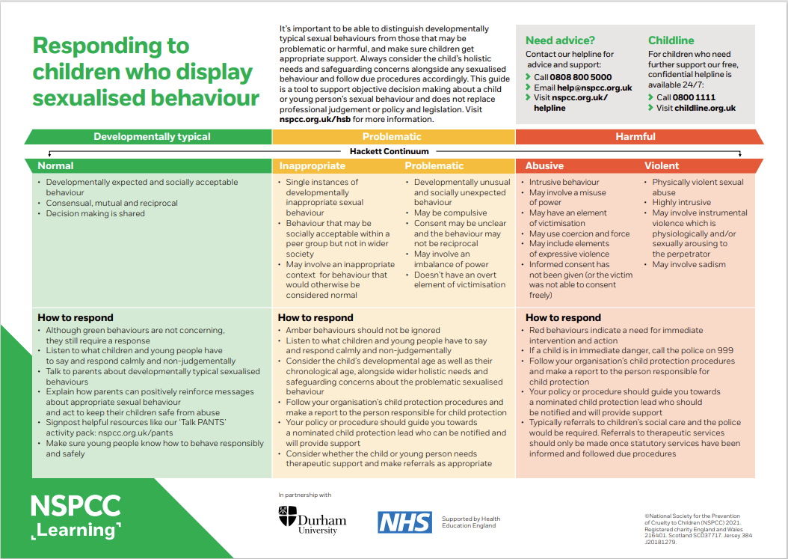Simon Hackett (2010) has proposed a continuum model to demonstrate the range of sexual behaviours presented by children and young people, from those that are normal, to those that are highly deviant:
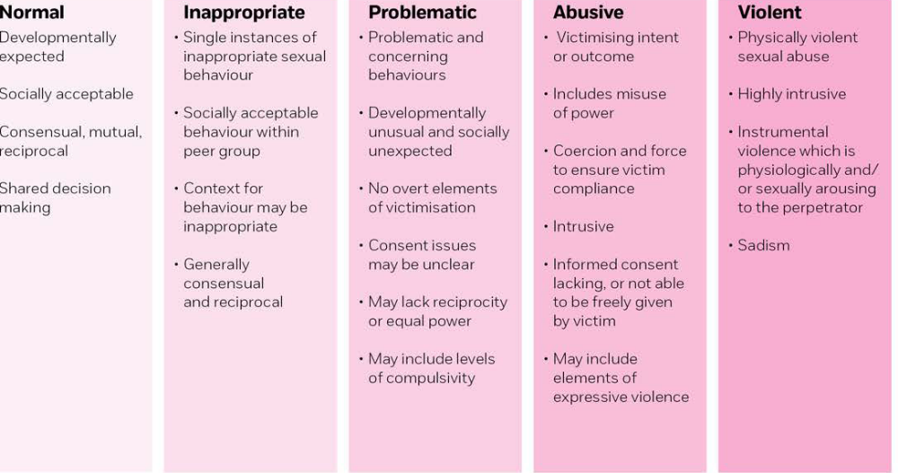
Source: Understanding sexualised behaviour in children | NSPCC Learning

Appendix 2: Useful Publications and Websites
Government Publications
Keeping Children safe in Education
Advice to schools and colleges on gangs and youth violence
Preventing bullying
Review of sexual abuse in schools and colleges (June 2021)
Other useful documents
Sharing nudes and semi-nudes: advice for education settings working with children and young people (Updated March 2024)
UK Feminista: Sexism- It’s Just Everywhere. A study on sexism in schools, and how we tackle it
Child-on-child abuse
Farrer & Co - Child-on-child abuse toolkit
Anti-bullying Alliance: Develop Effective Anti-Bullying Practice
Stop it Now - What is Age appropriate?
NSPCC: Understanding Sexualised Behaviour in Children
NSPCC: Is this sexual abuse?
Online sexual harassment
Childnet: Project deSHAME- Digital Exploitation and Sexual Harassment Amongst Minors in Europe Understanding, Preventing, Responding
Appendix 3 – Spencer Academy Trust Needs and Risk Assessment
Version Number
Student Name |  |  |  |  |  | Risk Rating (High/Medium/Low):
D.o.B.
School
Completed by
Reviewed by
Time & Location of Incident
Action Required to Make Location Safer (if applicable)
Area of Risk | Considerations |  |  | Child A | Child B |  |  | Notes | Actions
Details of Risk | - How serious is the incident? Was it a crime?  - Do we need to plan to limit contact between the children involved? (If the allegation relates to rape, assault by penetration, or sexual assault, the answer is automatically yes)  - How did we find out about it? Was it reported directly or by someone else with knowledge of the incident?
Social Risks | - Do the children share a peer group? Are people in their friend group likely to take sides?  - Do they both attend our Academy?  - Do other people know about the incident? Do those people understand:  - Who can they talk to if they have concerns about the people involved, or about their own safety and wellbeing?  - The importance of confidentiality  - If, and how, they may need to be involved in any further investigations.  - Are they likely to be the subject of gossip, bullying or further harassment?  - Have there been previous incidents of sexually inappropriate behaviour within their peer group(s)?  - Do they risk being alienated from their friend group(s) because of this incident?
Physical Risks | - Do they feel, or continue to feel, physically threatened by the other child?  - Do we have reason to believe they pose a continued risk to the safety and wellbeing of the victim, or other students and staff?  - Are they at risk of physical harm because of this incident (for example, bullying or ‘retribution’ by peers)  - Do they share classes/break times/etc.?  - Are they likely to come into contact with each other (or anyone else involved in/with knowledge of the incident) outside of the Academy? How can such contact be limited?
Environment Risks | - Do they live in a home where violence or abuse has occurred?  - Do they live in or near an area or location known to police to be high risk for sexual harassment or assault?  - Are they active on social media? If so, how? Do they know how to protect themselves from online grooming?  - What activities do they take part in outside of the Academy?  - Are parents clear about:  - How the Academy (and partner agencies) are handling the incident?  - Confidentiality?  - The conduct expected of them while an investigation is ongoing?
Reviews |  | Agreed Review frequency:
Date |  | Updates Made |  |  |  |  | Reason for Update |  |  | Updated by

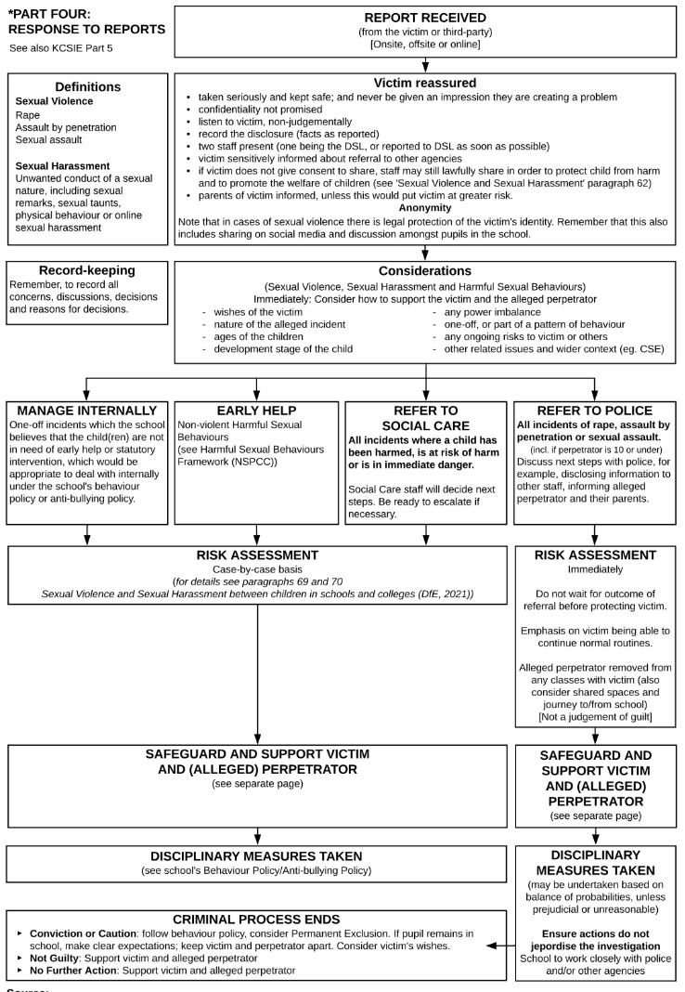
Appendix 4 – Flowchart: Managing Reports of Sexual Violence/Sexual Harassment
Managing Reports of Sexual Violence/Sexual Harassment

